Car Seats Data Analysis

Chathurani Ekanayake

2023-02-18

install.packages(“ISLR”)

# 01. Load ISLR and get the Data set

library("ISLR")  
data("Carseats")

# 02. Summary of Data set

library("ISLR")  
summary(Carseats)

## Sales CompPrice Income Advertising   
## Min. : 0.000 Min. : 77 Min. : 21.00 Min. : 0.000   
## 1st Qu.: 5.390 1st Qu.:115 1st Qu.: 42.75 1st Qu.: 0.000   
## Median : 7.490 Median :125 Median : 69.00 Median : 5.000   
## Mean : 7.496 Mean :125 Mean : 68.66 Mean : 6.635   
## 3rd Qu.: 9.320 3rd Qu.:135 3rd Qu.: 91.00 3rd Qu.:12.000   
## Max. :16.270 Max. :175 Max. :120.00 Max. :29.000   
## Population Price ShelveLoc Age Education   
## Min. : 10.0 Min. : 24.0 Bad : 96 Min. :25.00 Min. :10.0   
## 1st Qu.:139.0 1st Qu.:100.0 Good : 85 1st Qu.:39.75 1st Qu.:12.0   
## Median :272.0 Median :117.0 Medium:219 Median :54.50 Median :14.0   
## Mean :264.8 Mean :115.8 Mean :53.32 Mean :13.9   
## 3rd Qu.:398.5 3rd Qu.:131.0 3rd Qu.:66.00 3rd Qu.:16.0   
## Max. :509.0 Max. :191.0 Max. :80.00 Max. :18.0   
## Urban US   
## No :118 No :142   
## Yes:282 Yes:258   
##   
##   
##   
##

nrows <- nrow(Carseats)  
print(paste("Number of rows:",nrows))

## [1] "Number of rows: 400"

# 03. Find the maximum value of Advertising

M <- max(Carseats$Advertising,na.rm = TRUE)  
print(paste("Maximum value of Advertising:",M))

## [1] "Maximum value of Advertising: 29"

# 04. Calculate IQR

I <- IQR(Carseats$Price)  
print(paste("IQR of price:", I))

## [1] "IQR of price: 31"

# 05. Plot Sales and Price data

library(ggplot2)  
ggplot()+geom_point(data=Carseats,mapping = aes(x=Sales, y=Price),color="navy")

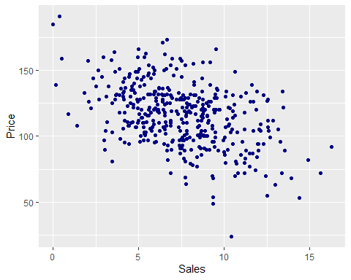

correlation <- cor(Carseats$Sales,Carseats$Price)  
print(correlation)

## [1] -0.4449507

#According to the correlation value there is a moderate negative relationship between sales and the price of car seats. The negative correlation value indicates that the price of Car Seats and Sales of Car Seats have a negative relationship. Simply it means when the price of Car Seats increases, the Sales of Car Seats go down. It is important to note that correlation value does not indicate causation.